2040 Amsterdam Road, Belgrade, MT 59714  Phone: 586-8232  Email: [dean@jds-sprinklers.com](mailto:dean@jds-sprinklers.com)

**SNOW REMOVAL SERVICE AGREEMENT**

**September 30, 2016**

|  |
| --- |
| **Customer**  Wheatland Hills Homeowners Association |
| **Contact**  Rocky Ross **** 5105 Cimmeron Drive **** Bozeman 59715  406-599-6703 (call or text) |
| **Nominal Dates of Service**  November 1, 2016 through March 31, 2017  Snow removal will occur as specified in the section *Work Description* below during this period, including weekends and holidays. Snow removal before or after these dates will be addressed on an on-call basis, with the same hourly rates specified in the section *Rates* below. |
| **Rates**  Snow removal and ice melt application are charged at $95.00 per hour, with the clock starting when Wheatland Hills is reached and ending when Wheatland Hills is left.  Ice Melt (material) is charged at $25 per ?-pound bag. |
| **Work Description**  Early-morning snow removal will be completed in the order specified here given overnight snowfall of at least 2 inches. (1) The Itana Circle and Cimmeron Drive street entrances from Springhill Road will be plowed and ice melt applied (so that it can begin working immediately) for a distance above each entrance as determined by the plower in conjunction with the Wheatland Hills Board. (2) Plowing will then continue with the bus routes—Itana Circle, Justin Lane, and Cimmeron Drive—with these streets cleared before 7:00 AM. (3) Thereafter, the remaining streets in Wheatland Hills will be plowed.  Afternoon snow removal will follow the same protocol as early morning snow removal given daytime snowfall of at least 2 inches, with the bus routes being cleared by 3:00 PM.  Additionally, the contractor will monitor street conditions in conjunction with the Wheatland Hills Board and plow and/or apply ice melt as needed even if new snow accumulation is less than 2 inches. |
| **Equipment**  JD’s has 4 4x4 Chevy plow trucks, one dedicated to Wheatland Hills. If there are mechanical issues with that truck, there is a spare to take its place until it is repaired. |

|  |
| --- |
| **Ice Melt Application**  JD’s currently uses a walk-behind spreader for distributing ice melt. We are looking into other options for ice melt distribution. Unless requested otherwise, JD’s will use magnesium chloride ice melt. For a comparison of ice melt options, view <http://www.consumerreports.org/cro/2014/02/best-ice-melts/index.htm>. |
| **Drivers**  JD’s currently employs 4 snowplow drivers. One driver is dedicated to Wheatland Hills. If for some reason this driver is not able to do his route, there are other drivers on call to fill in. |
| **Extreme Snow Removal**  If haul-off snow removal is necessary as a result of unusually heavy snow accumulation, JD’s has large dump trucks to haul snow away and also works with a vendor who would perform the removing of the snow at the rate of $125.00 per hour, including equipment costs. |
| **On-Call Slush Removal**  On days that warm up and slush is present on the roads, JD’s will plow the slush off of the roads to help prevent ice buildup if called by Wheatland Hills to do so. |

**Prepared by**: Dean Holskey, JDSS Inc.

I accept the snow removal proposal and agree to pay the applicable charges with 10 days of receipt of invoice. Interest will be accrued at 15% of unpaid balance per annum, 1.25% per month. In event of nonpayment, the customer agrees to pay all costs associated with collection of debt, including attorney fees.

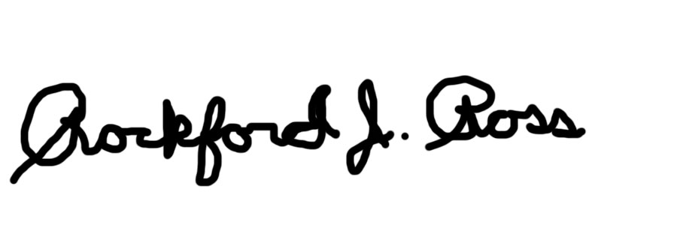

Authorized signature: Date: September 30, 2016